Week 07
Problem Statement:
Sunny and Johnny like to pool their money and go to the ice cream parlor. Johnny
never buys the same flavor that Sunny does. The only other rule they have is that they
spend all of their money.
Given a list of prices for the flavors of ice cream, select the two that will cost all of
the money they have.
For example, they have m = 6 to spend and there are flavors costing cost = [1, 2, 3,
4, 5, 6]. The two flavors costing 1 and 5 meet the criteria. Using 1-based indexing, they are
at indices 1 and 4.
Complete the code in the editor below. It should return an array containing the
indices of the prices of the two flavors they buy, sorted ascending.
It has the following:
• m: an integer denoting the amount of money they have to spend
• cost: an integer array denoting the cost of each flavor of ice cream
Program:
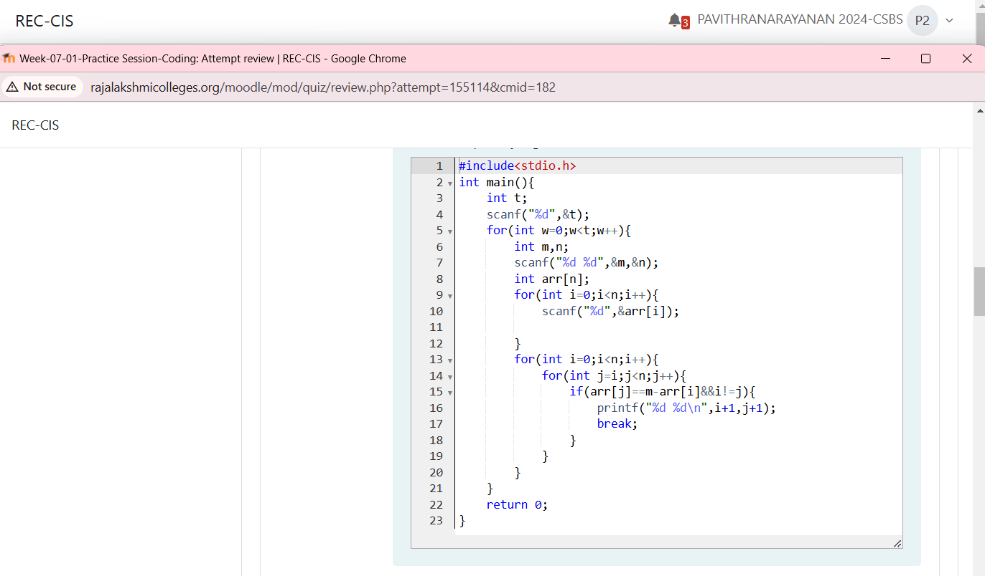
Output;
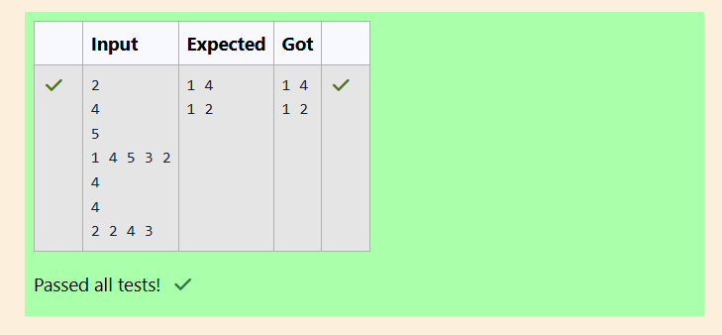
Problem Statement:
Numeros the Artist had two lists that were permutations of one another. He was very proud.
Unfortunately, while transporting them from one exhibition to another, some numbers
were lost out of the first list. Can you find the missing numbers?
As an example, the array with some numbers missing, arr = [7, 2, 5, 3, 5, 3]. The original
array of numbers brr = [7, 2, 5, 4, 6, 3, 5, 3]. The numbers missing are [4, 6].
Program:
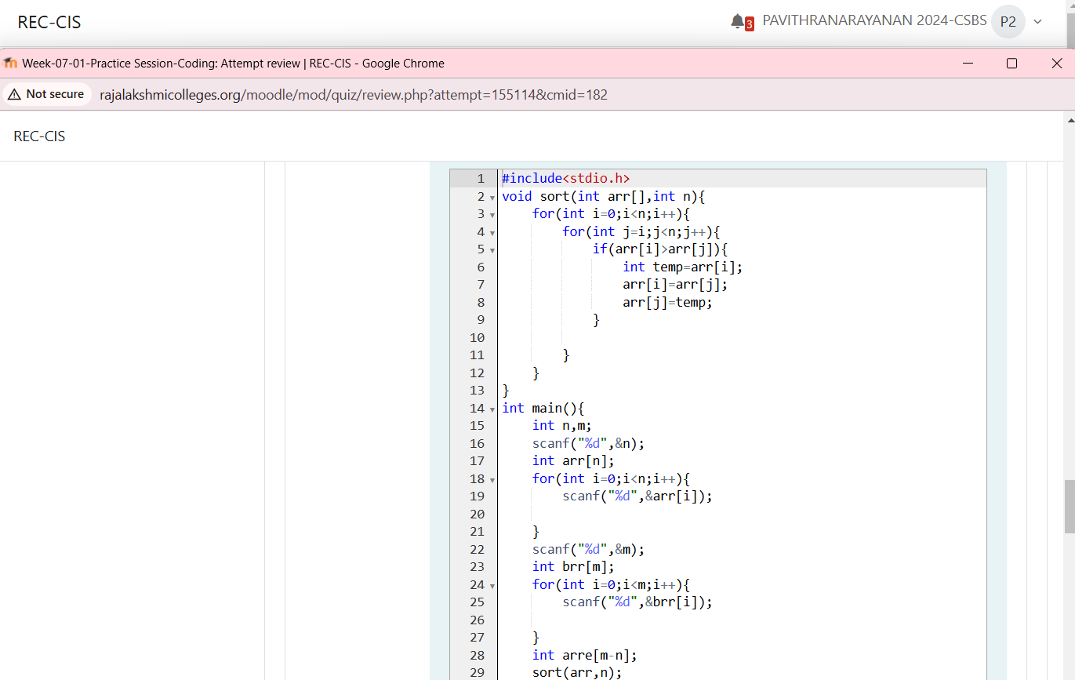
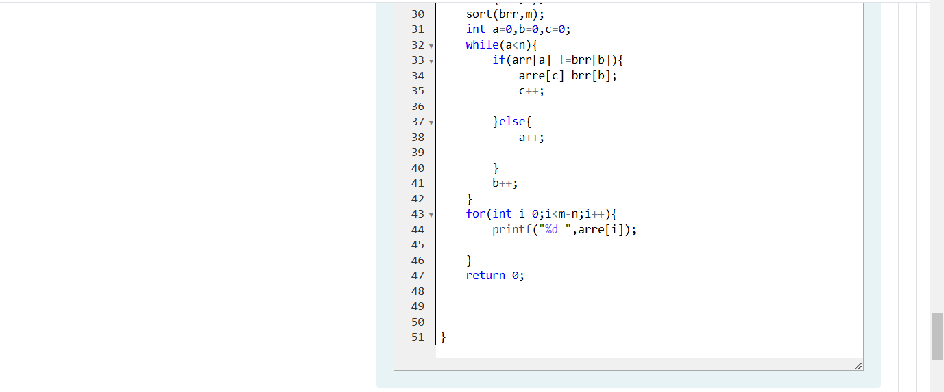
Output:
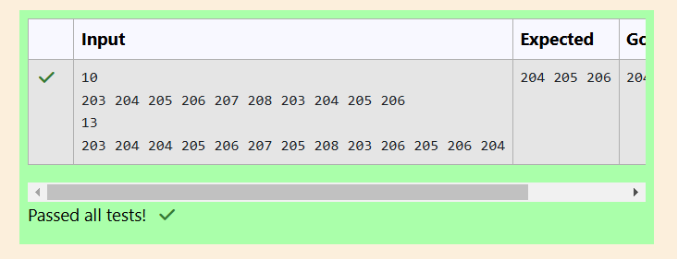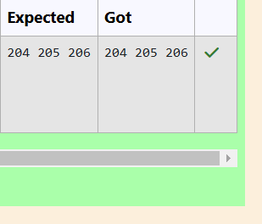
Problem Statement:
Watson gives Sherlock an array of integers. His challenge is to find an element of
the array such that the sum of all elements to the left is equal to the sum of all elements to
the right. For instance, given the array arr = [5, 6, 8, 11], 8 is between two subarrays that
sum to 11. If your starting array is [1], that element satisfies the rule as left and right sum
to 0. You will be given arrays of integers and must determine whether there is an element
that meets the criterion.
Complete the code in the editor below. It should return a string, either YES if there
is an element meeting the criterion or NO otherwise. It has the following: arr: an array of
integers
Input Format
The first line contains T, the number of test cases.
The next T pairs of lines each represent a test case.
- The first line contains n, the number of elements in the array arr.
- The second line contains n space-separated integers arr[i] where 0 ≤ i < n.
Constraints: 1 ≤ T ≤ 10, 1 ≤ n ≤ 105, 1 ≤ arr[i] ≤ 2 x 104, 0 ≤ i ≤ n
Output Format
For each test case print YES if there exists an element in the array, such that the sum of the
elements on its left is equal to the sum of the elements on its right; otherwise print NO.
Sample Input 0
2
3
1 2 3
4
1 2 3 3
Sample Output 0
NO
YES
Program:
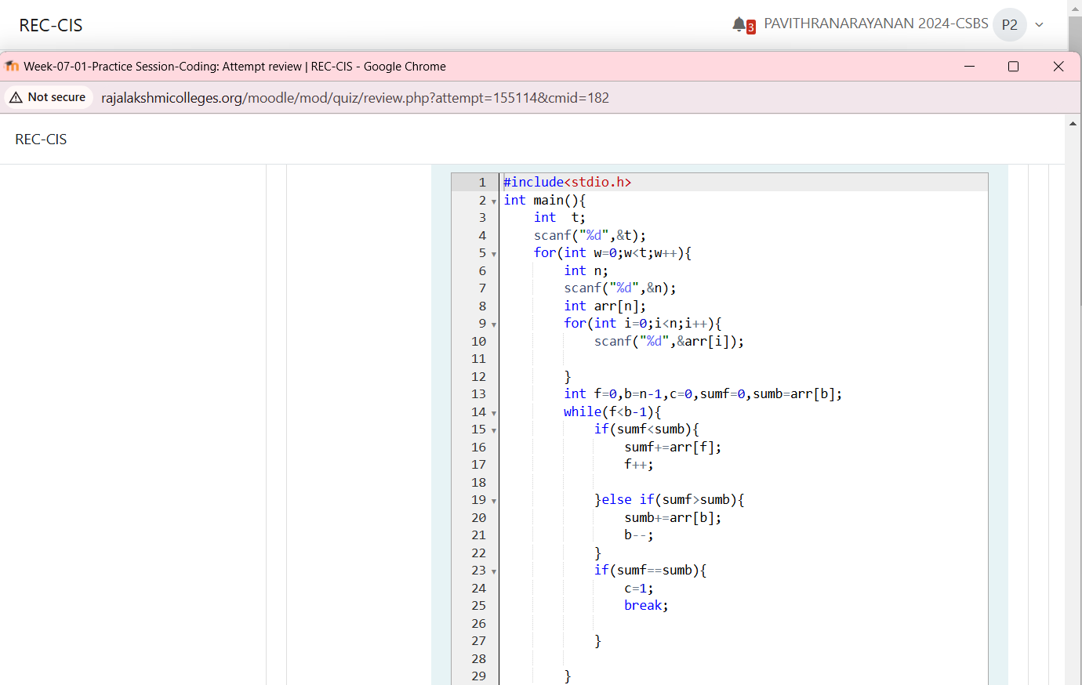 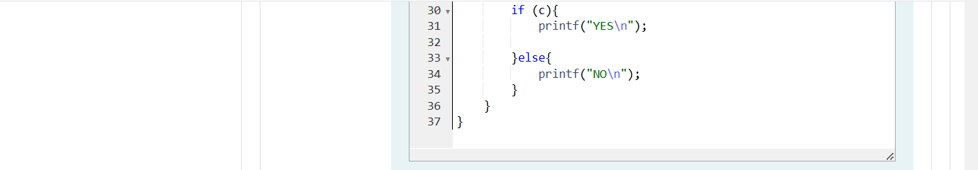
Output:
